**I-765 Online Filing Guidance**

This guide is designed to provide instructions on how to file an I-765. Specific instructions will vary depending on what category you are filing under. This guide is meant to aid you in the filing process but please consult USCIS’s guidelines to determine what additional forms or information you will need to submit alongside the I-765 in your specific category. Please click on this [link](https://www.uscis.gov/sites/default/files/document/forms/i-765instr.pdf) to consult USCIS guidelines on additional information that you may need to submit. **Only certain categories are eligible to file I-765 online, verify that you fall into an eligible category as listed in Step 6.**

1. To file online, you will first need to create an online account with USCIS. If you already have one, you can skip this step and go to step number 4.

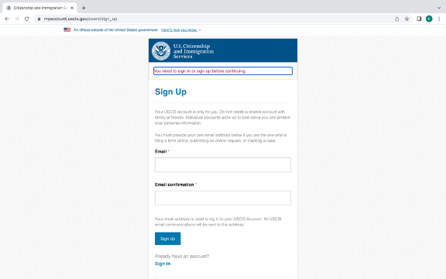

1. Please enter an email address that you regularly use and a password that you will remember. Then login to your USCIS account. If you already have a USCIS account, then this is the step you will begin with.

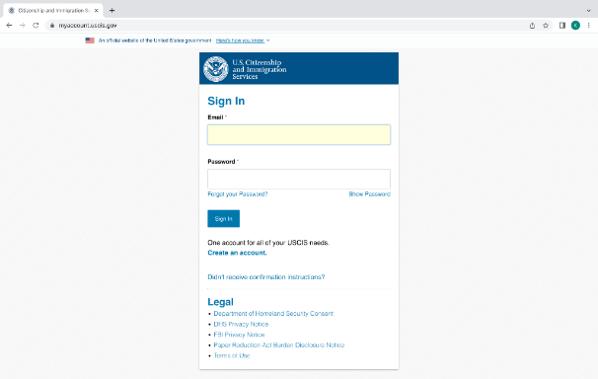

1. USCIS will then email you a verification code within a few seconds of you submitting your email. Enter this verification code to proceed to the next step.

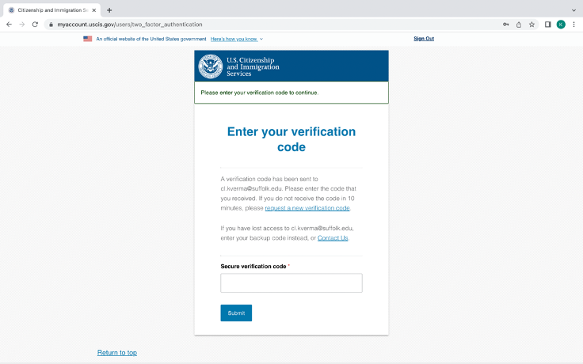

1. Select “File a form online”.

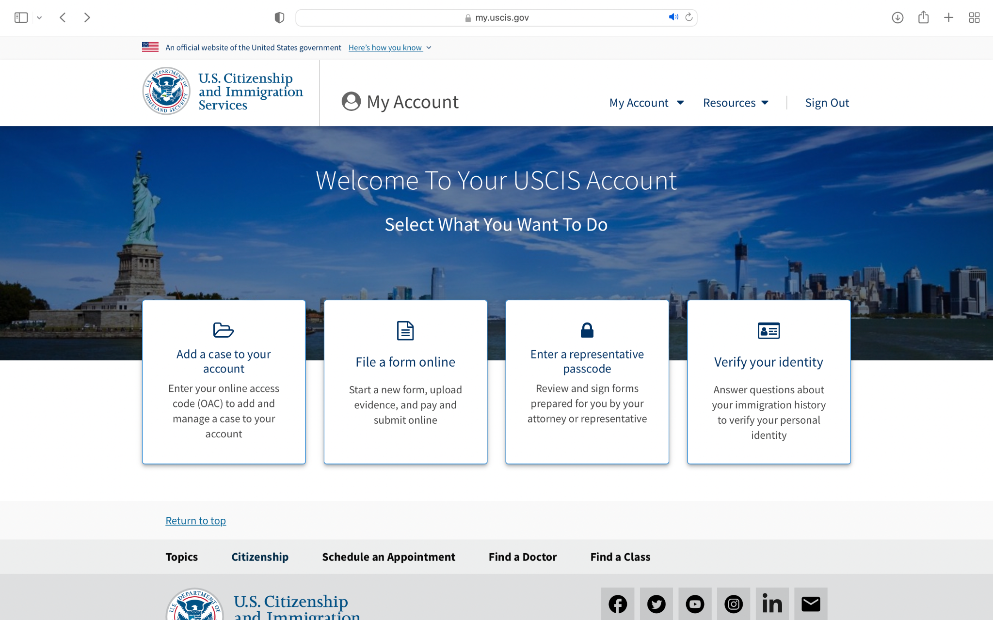

1. From the dropdown menu select “I-765, Application for Employment Authorization”

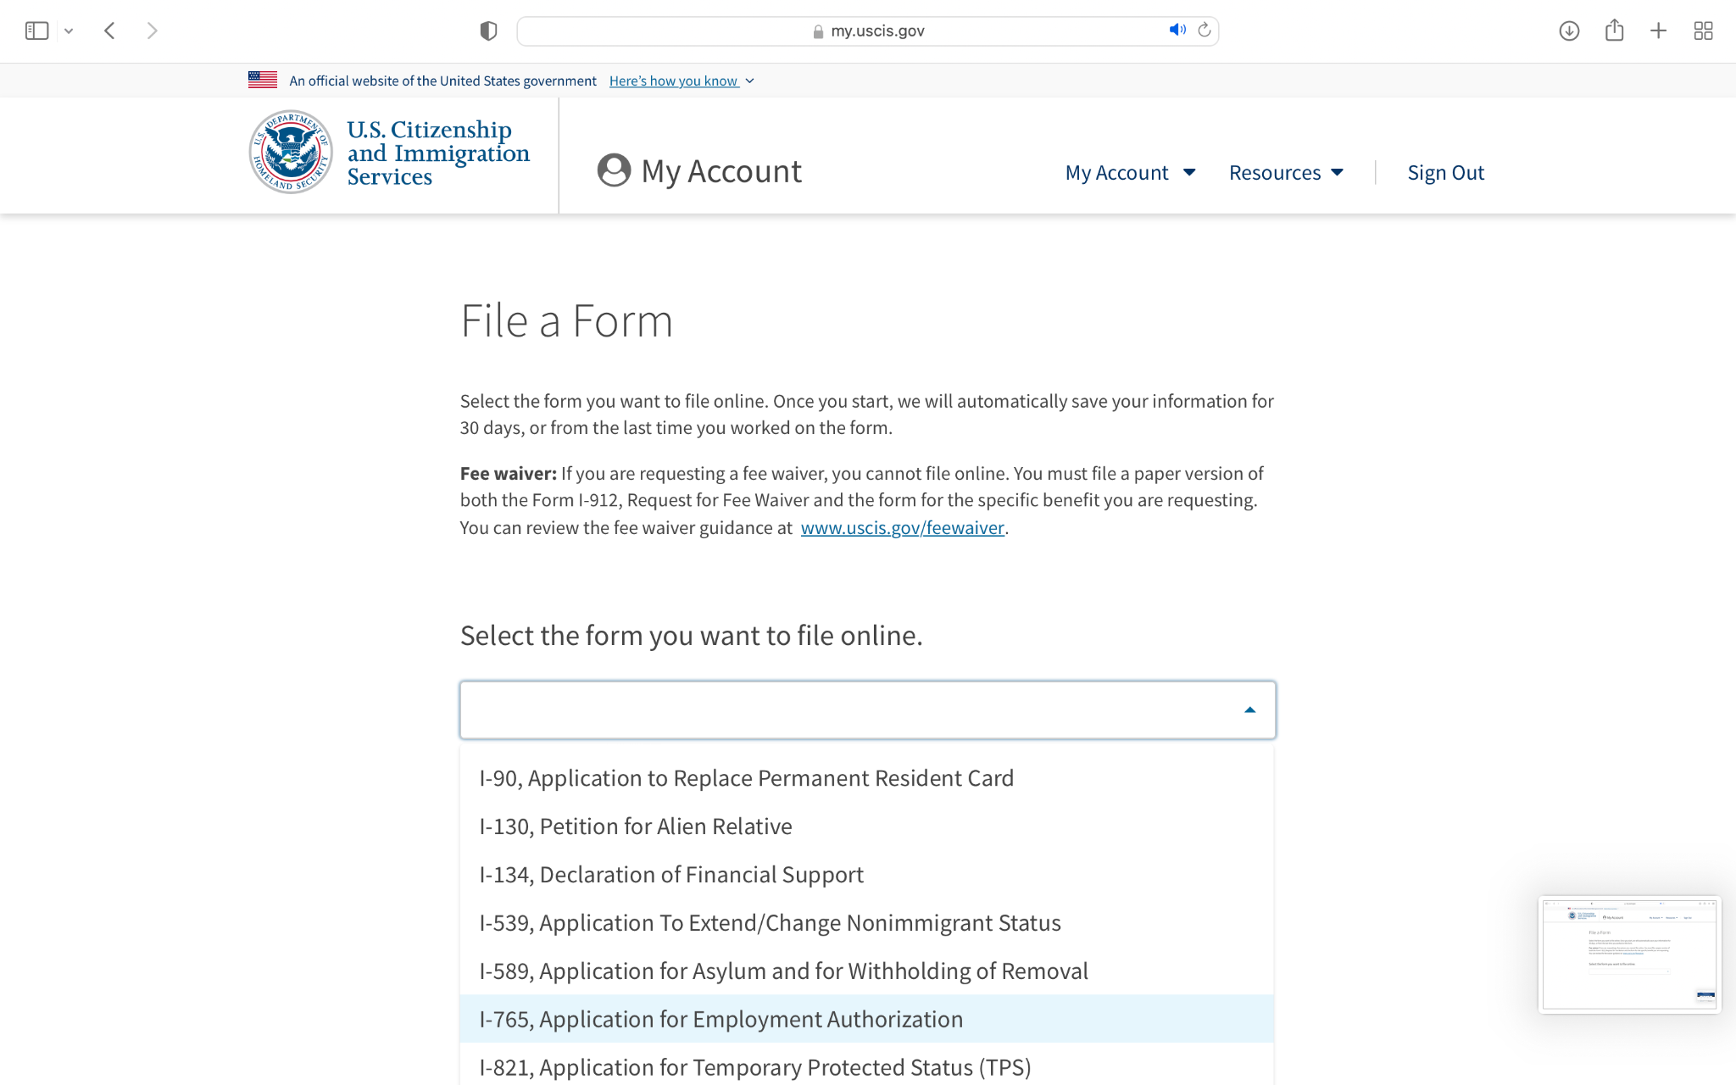

1. Confirm that you are applying under one of the eligibility categories that are able to file I-765 online, and click “Start Form”.

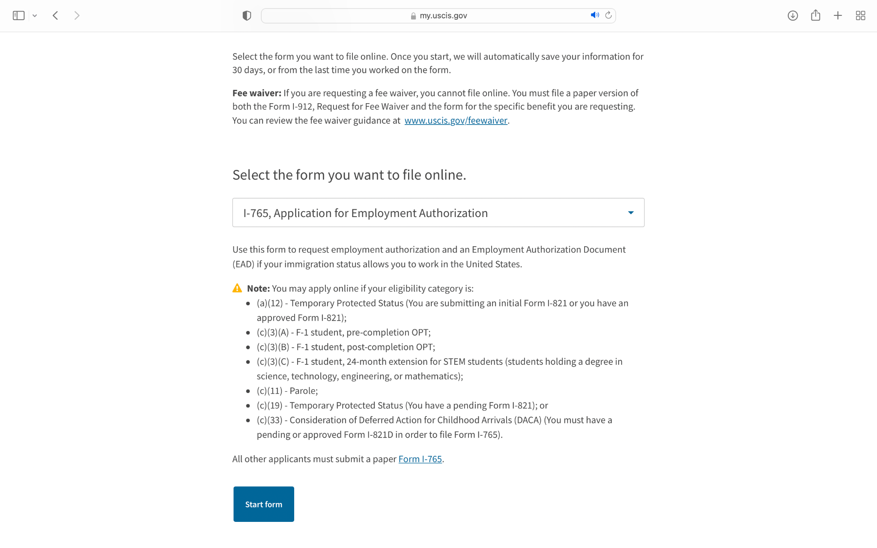

1. From the dropdown menu, select your eligibility category.

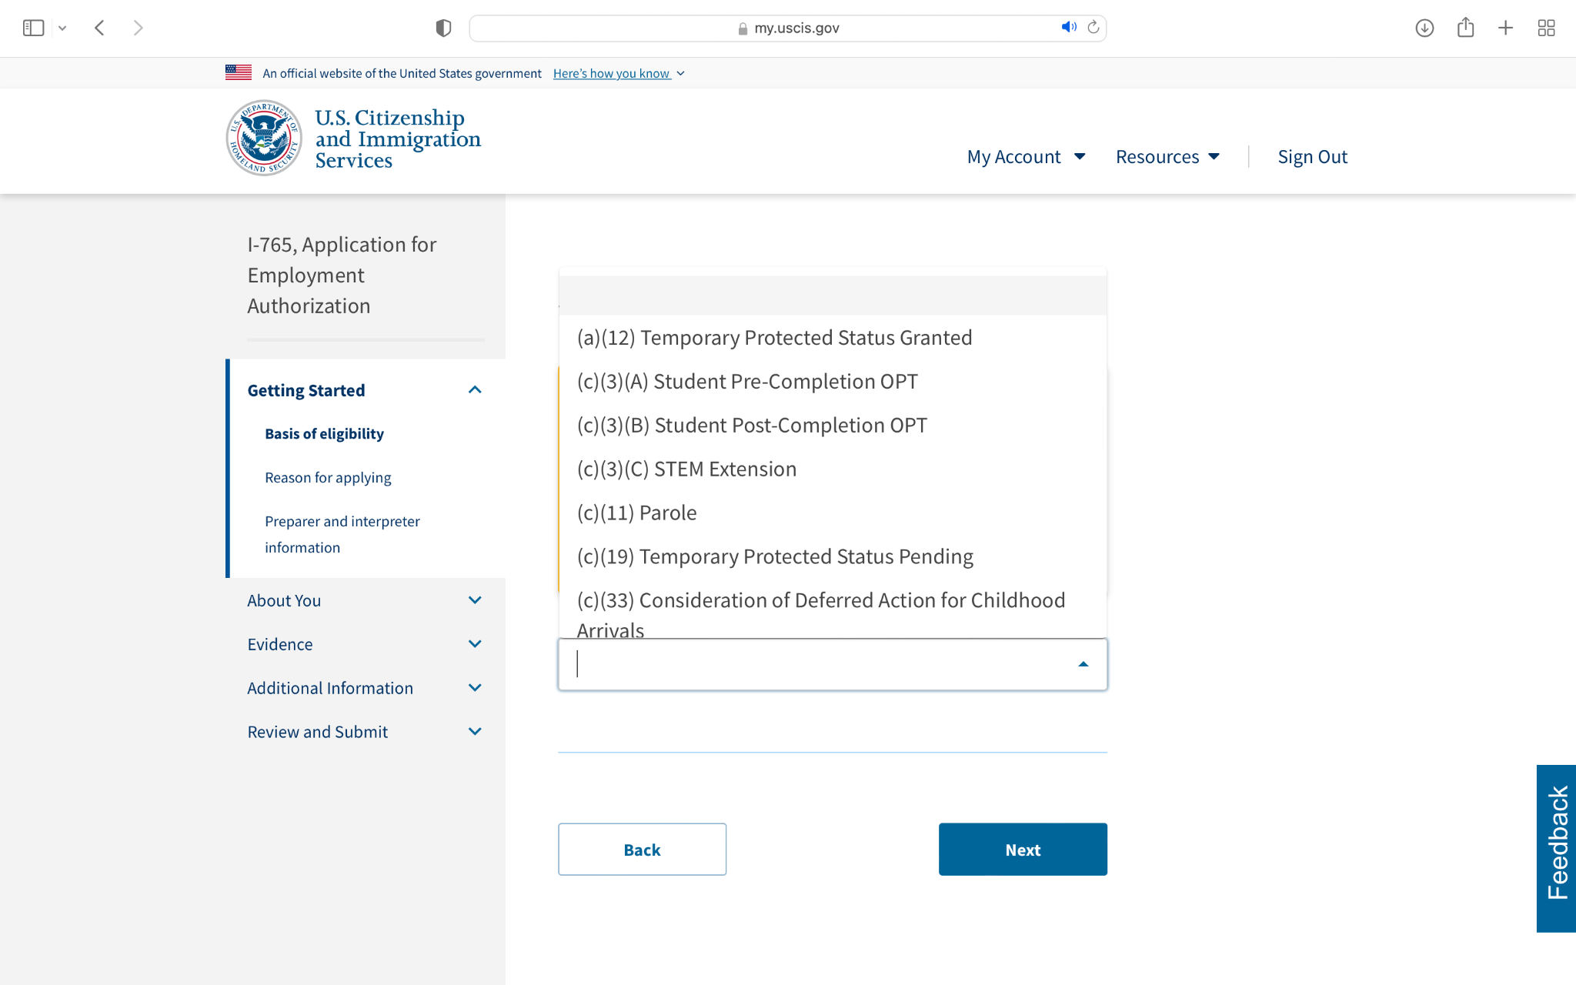

1. Enter your legal name and any name that you have previously used.

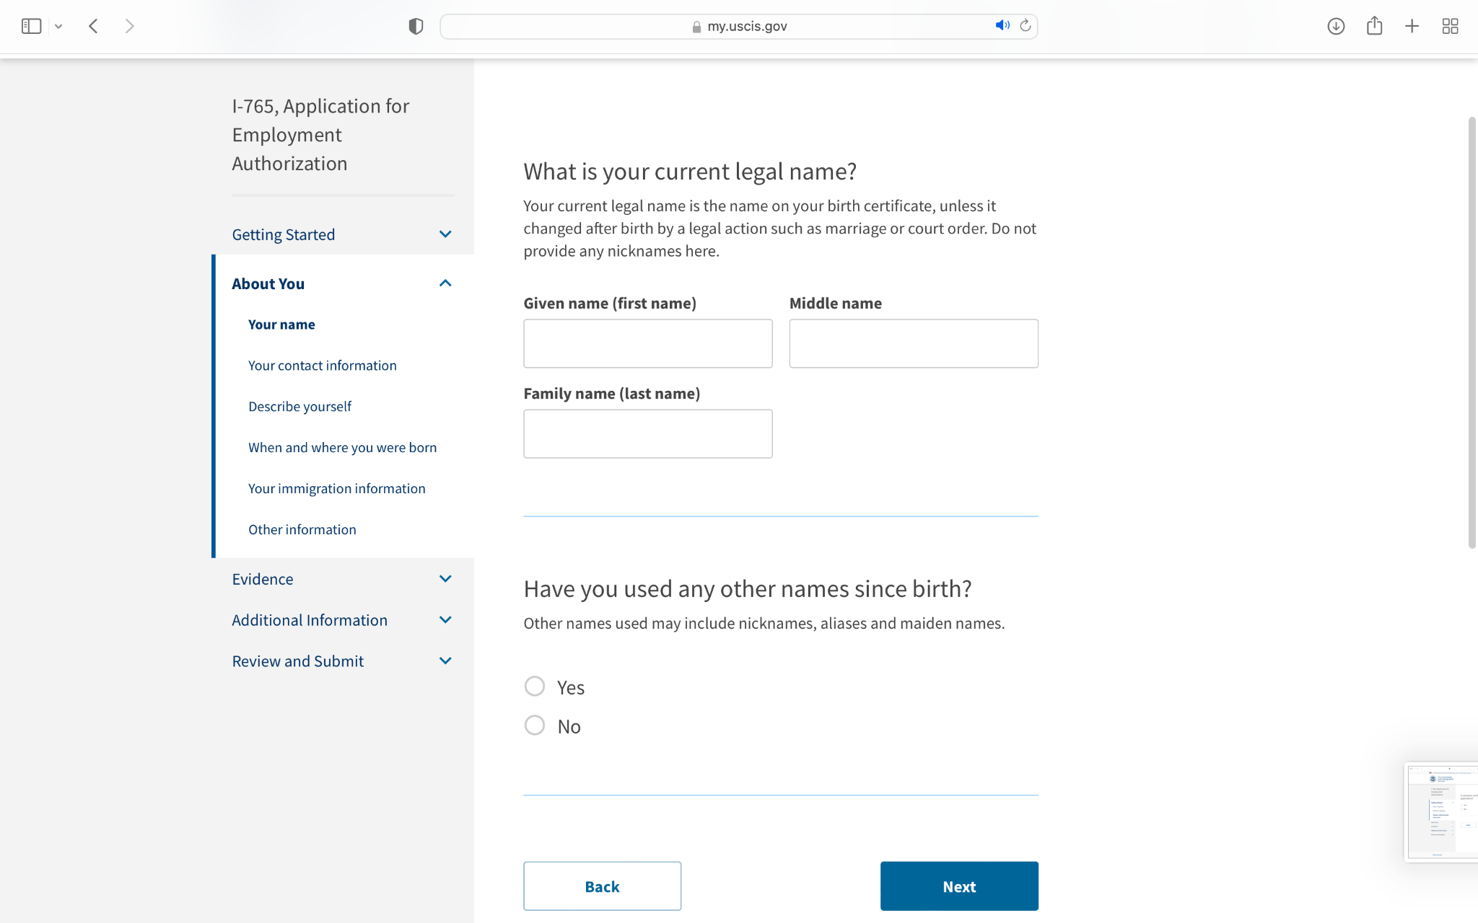

1. If you are applying for an I-765 for the first time, select the first option to question 1 under “Reasons for Applying”.

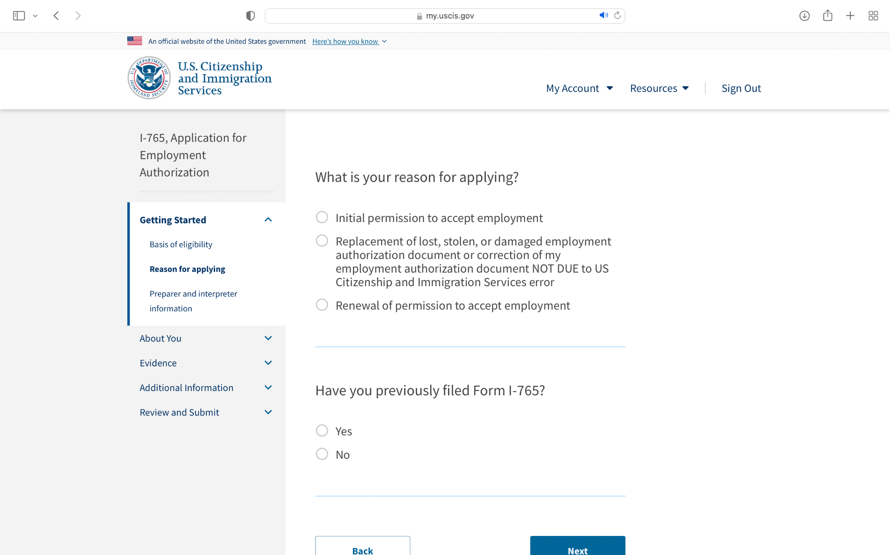

1. If you are not using an interpreter, select “No”.

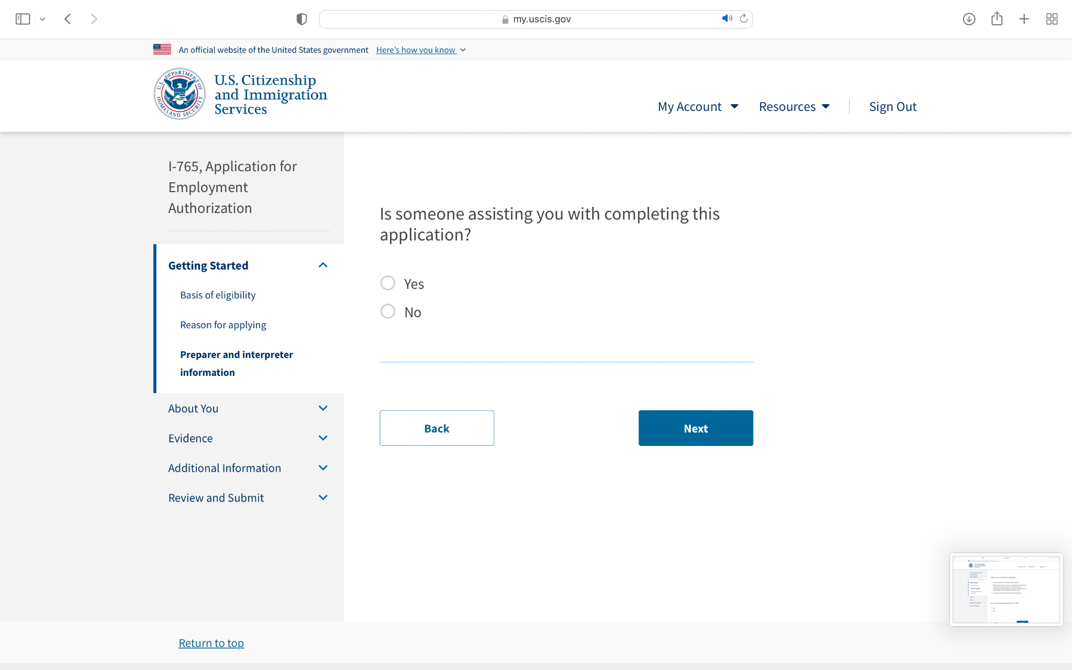

1. Enter your contact information beginning with your phone number and email address.

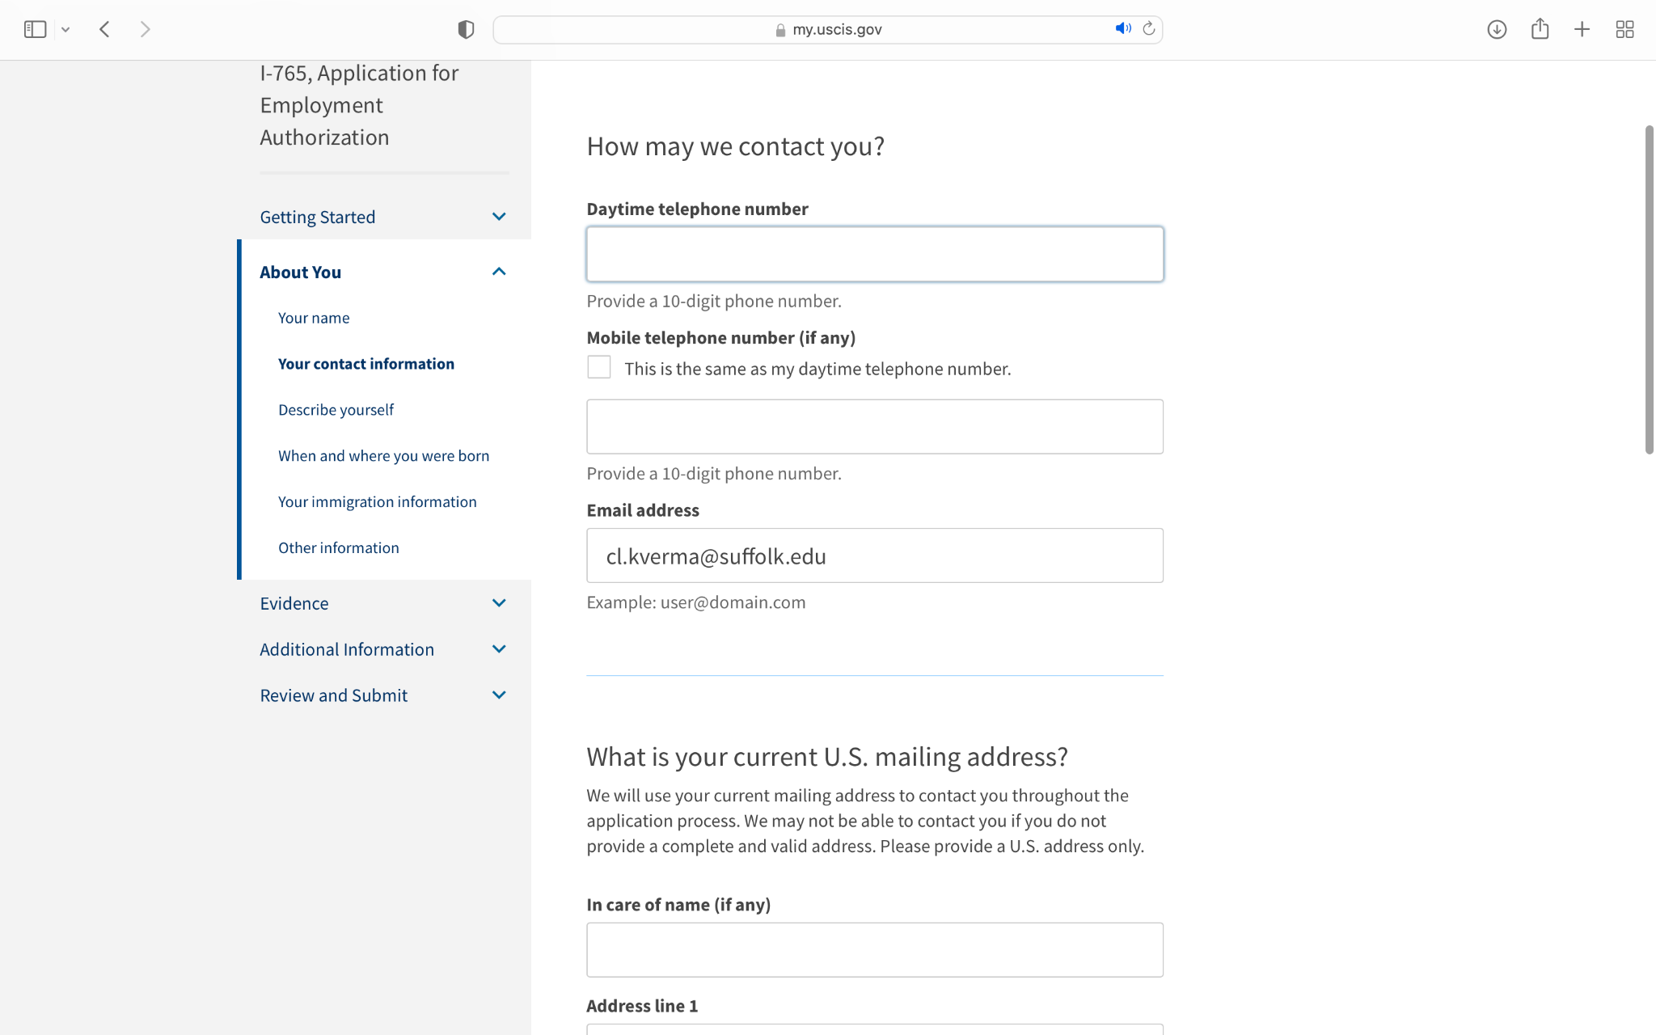

1. Then enter your current US mailing address and select whether or not your current US mailing address is the same as your physical address.

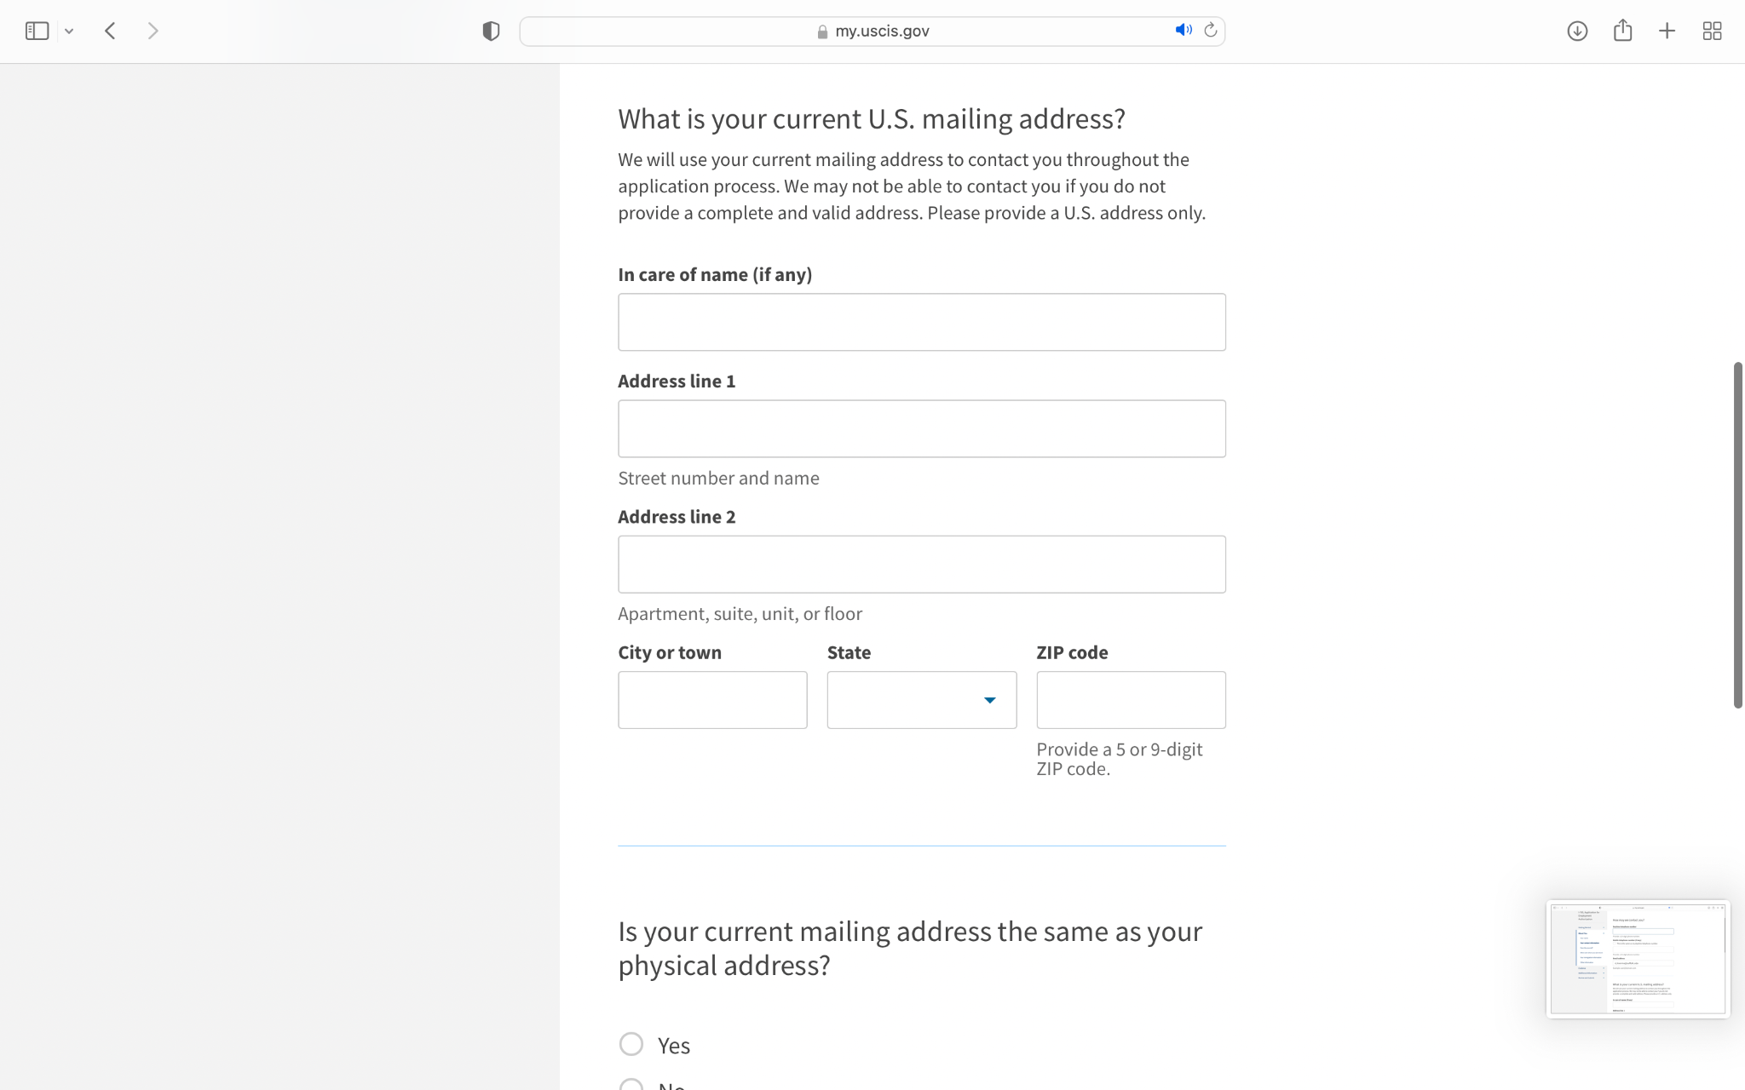

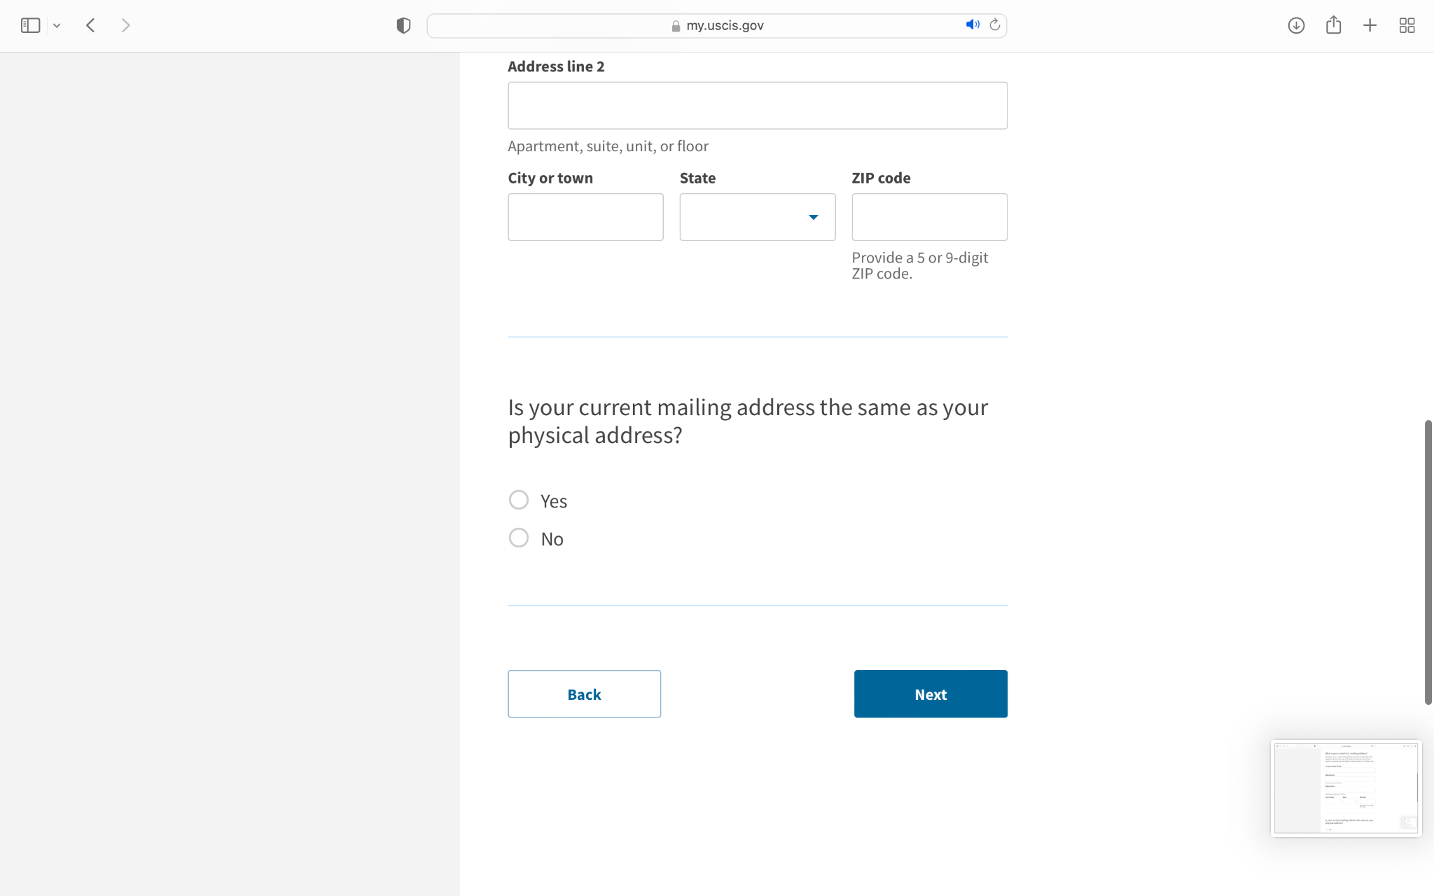

1. Then select your gender and your marital status.

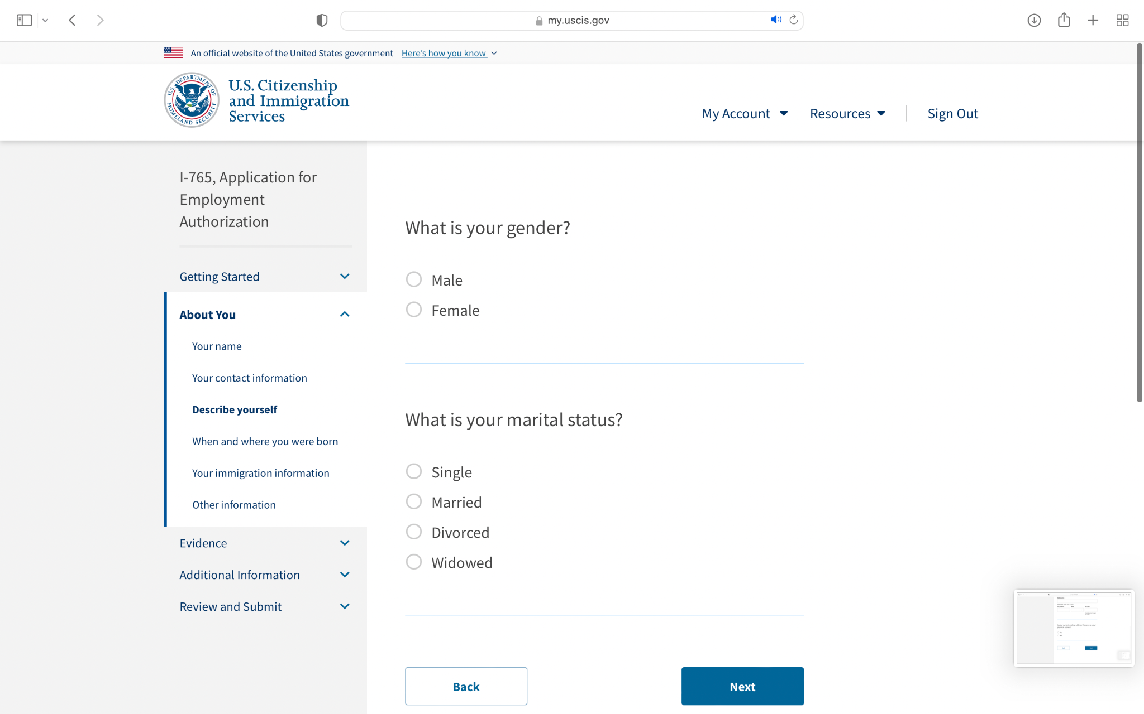

1. Then enter your city, village, or town of birth. Then enter your state or province of birth, and from the dropdown menu, select your country of birth.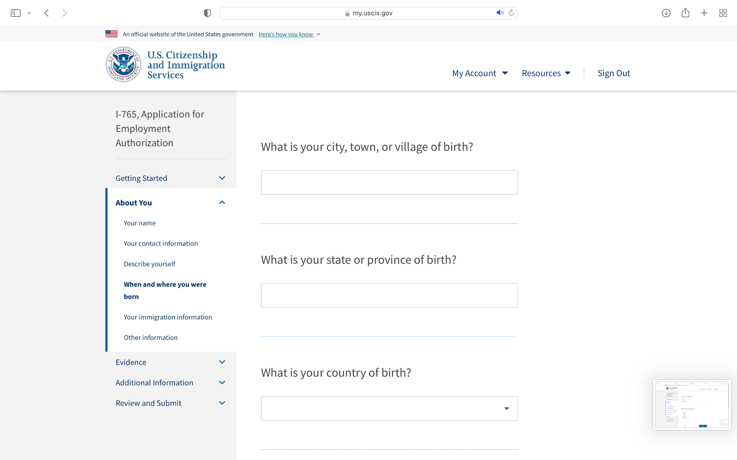
2. Then enter your date of birth.

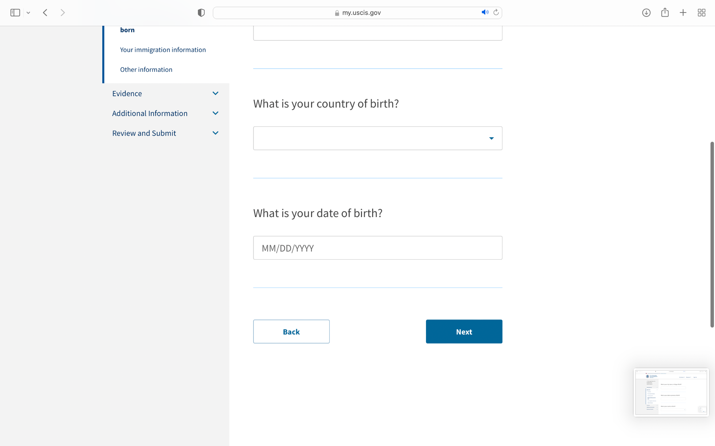

1. Then enter your most recent passport number of travel document number. Then enter the expiration date of your passport or travel document.

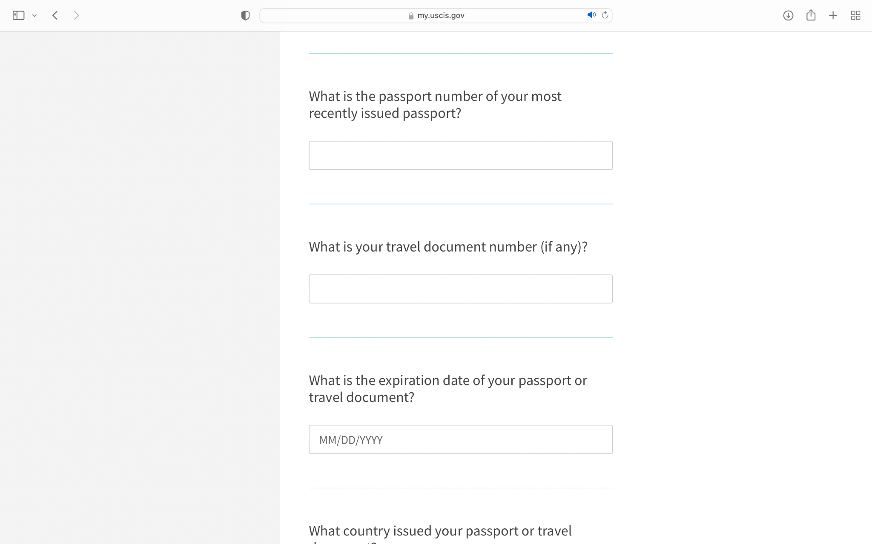

1. Then enter your immigration status or category. If you are a student or exchange visitor, enter your SEVIS number if you have one.

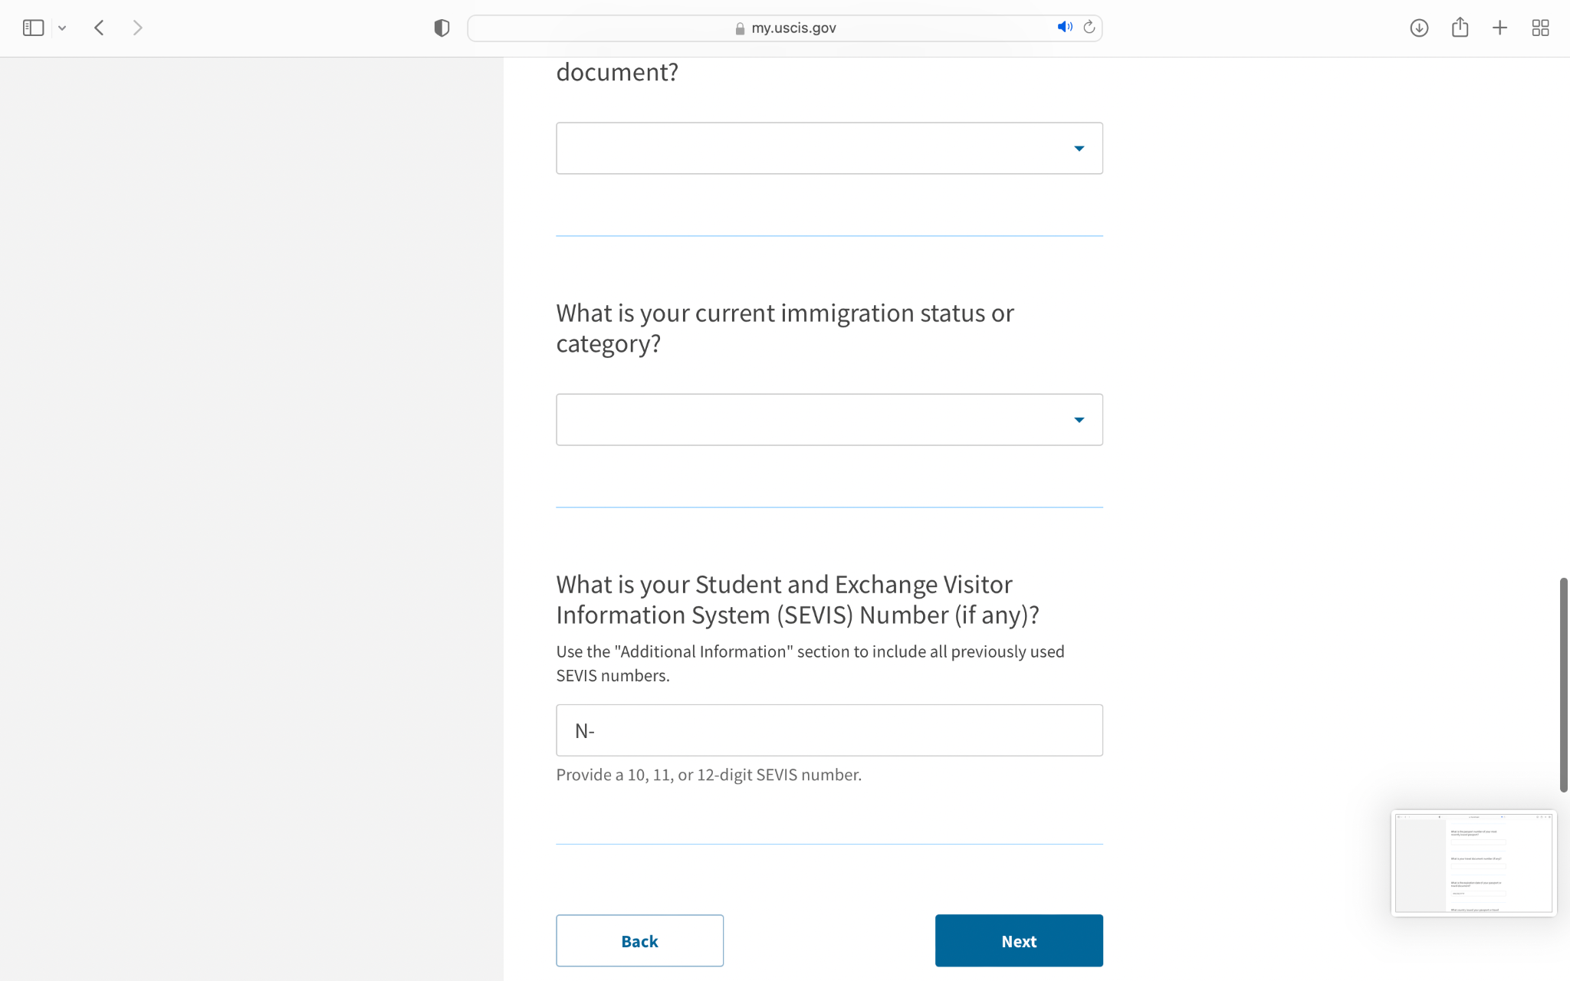

1. Then enter your A-number, or check the accompanying box if you do not have or know your A-number. Then enter your USCIS Online Account number, or select the accompanying box if you do not know or have a USCIS Online Account Number.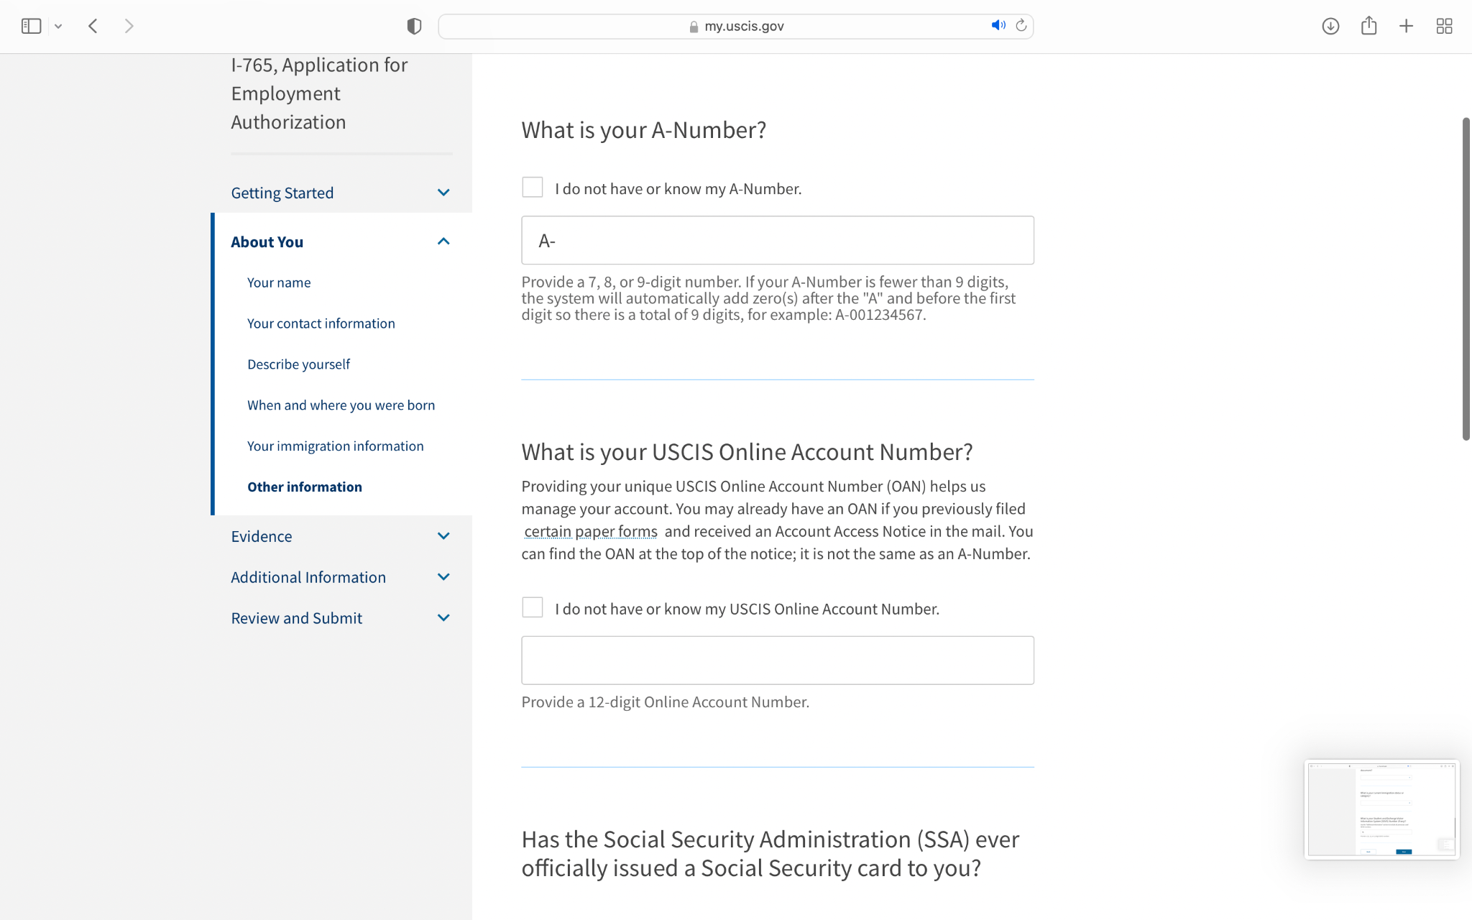
2. Select “Yes” if the SSA has issued you a card. If the SSA has not issued you a card yet, select “Yes” if you would like the SSA to issue you a card.

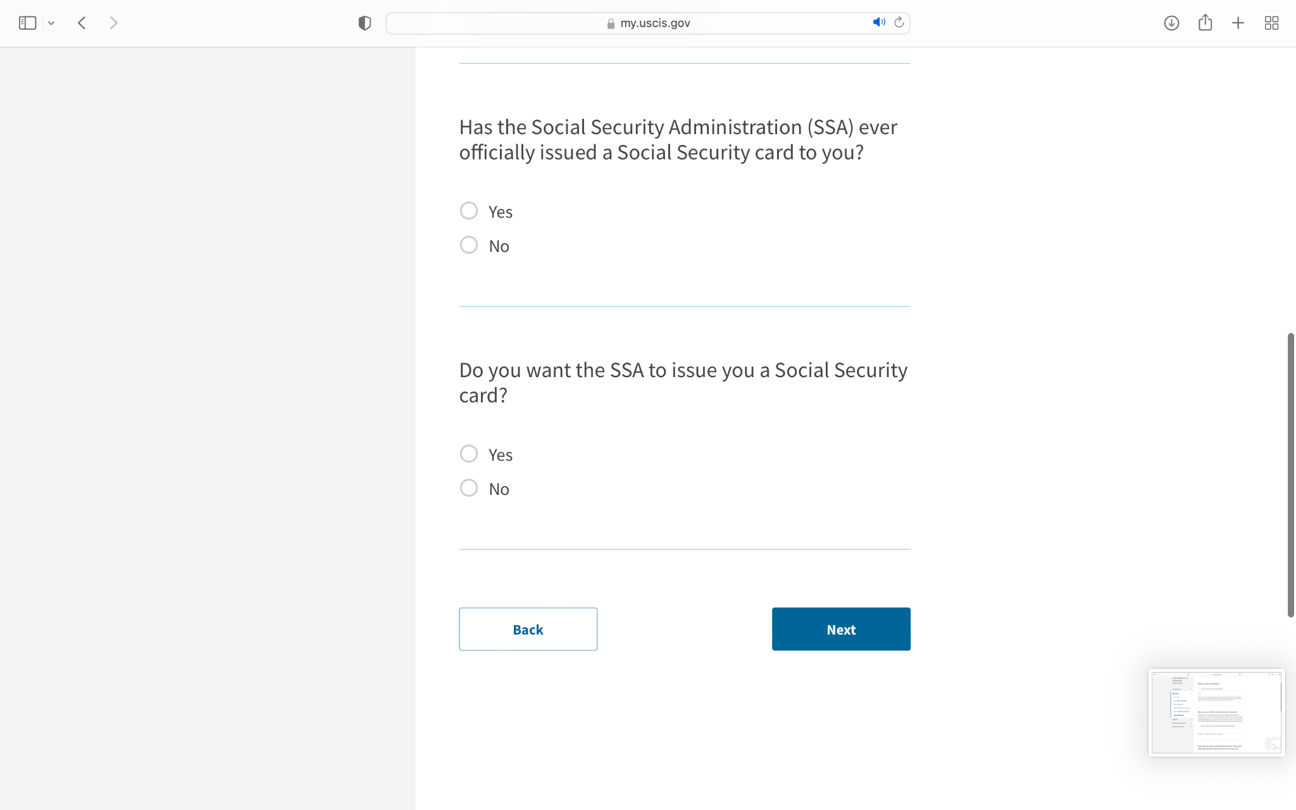

1. Then upload a 2x2 photo of you that meets USCIS requirements as listed below.

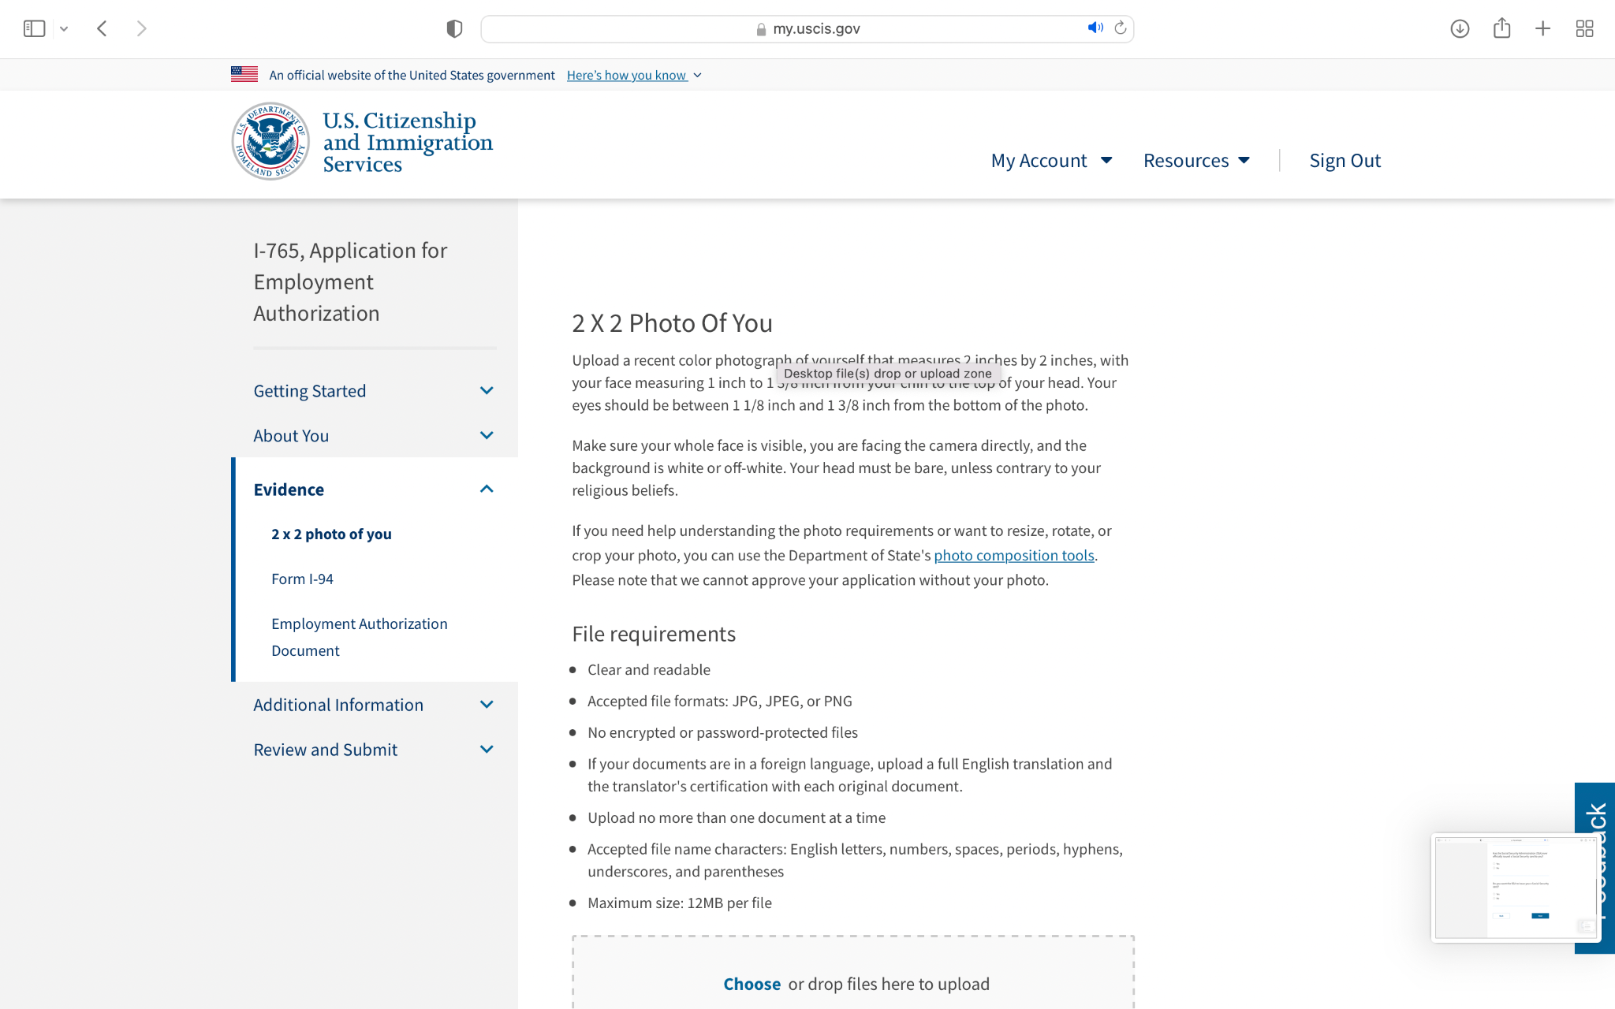

1. If there is any additional information that you would like to submit to the previous questions, click “Add a response”.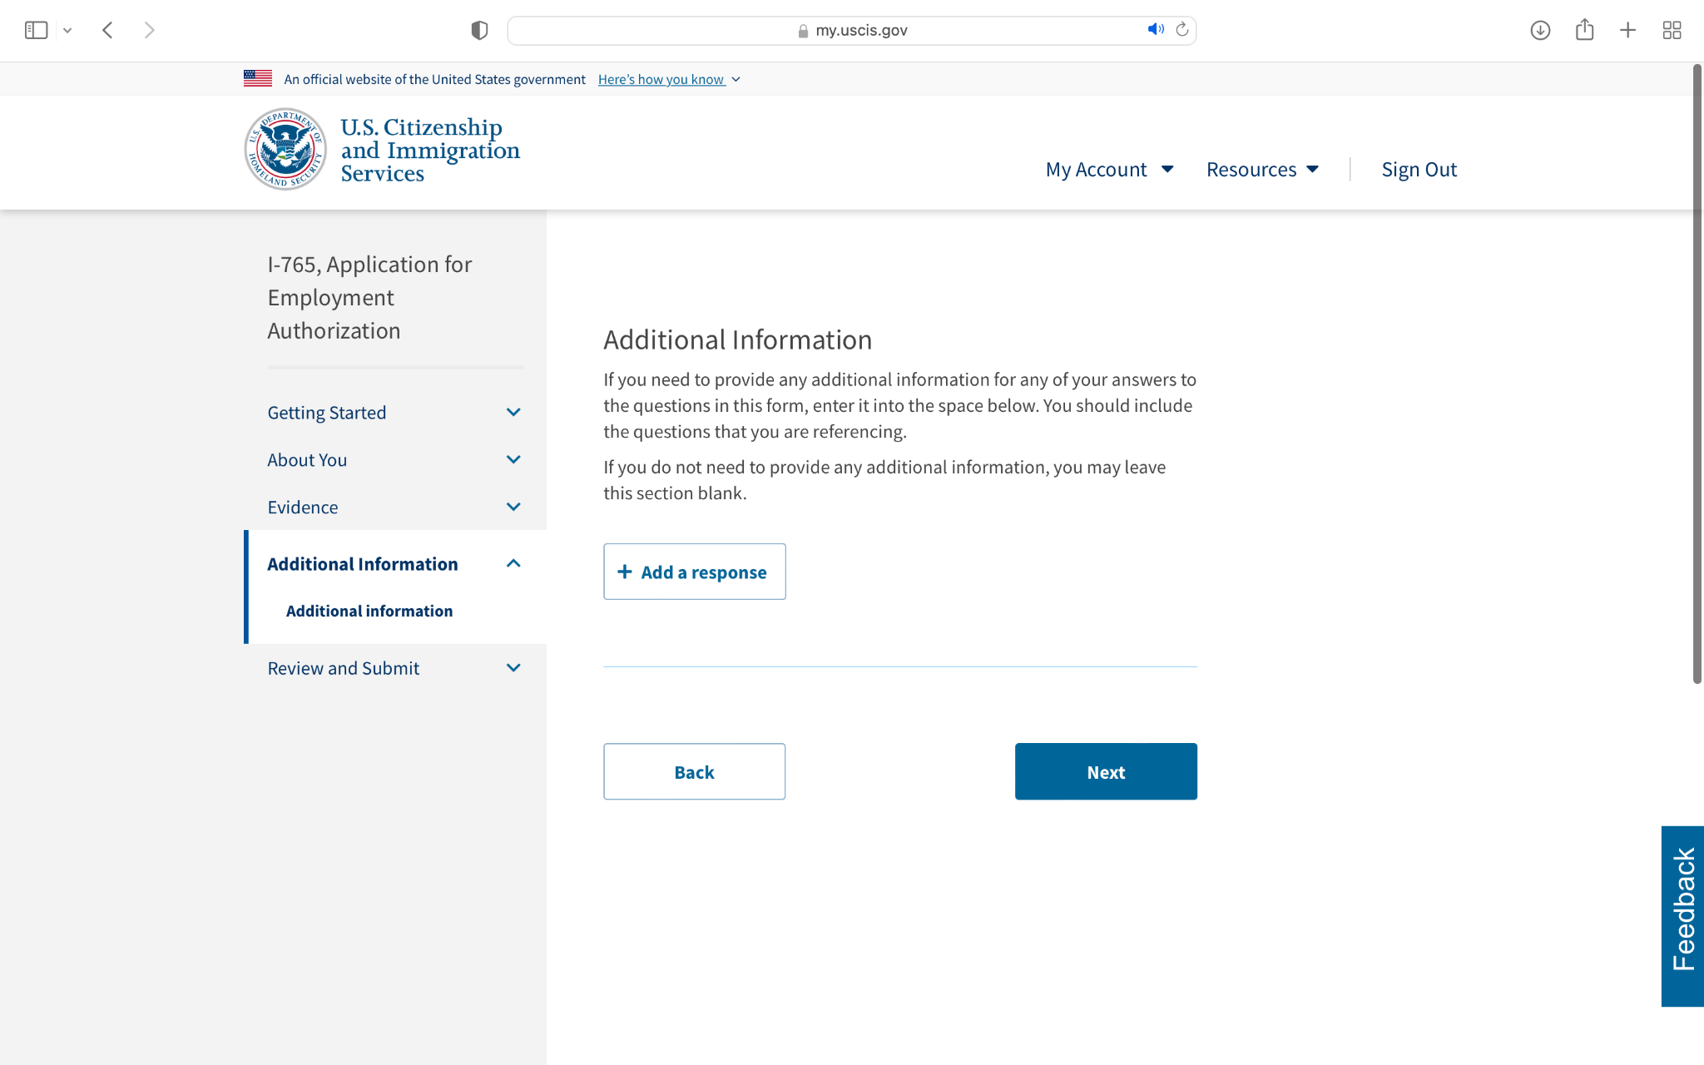
2. Then pay your filing fee, review your application, and click “Submit”.

